
School of Science, Engineering and Technology

Assessment Instrument Coversheet

Module Code: CMP210

Module Title: Ethical Hacking 1

Unit of Assessment: 1

Learning Outcomes 1,2,& 3
Assessed: (In addition, see module descriptor)
Lecturer: Colin McLean & Natalie Coull

Submission Date: Tuesday 18th December 2018 23:59hrs

Feedback Return Date: within 15 working days

Feedback Type: Electronic
(eg verbal, Blackboard)

Grading Criteria Refer to pages 3 - 5

Submission Requirements:

Your assessment must be submitted via Blackboard. The maximum file size which can be submitted is 20MB so you may need to reduce the size of any image files within your document.

Guidance on submitting via Blackboard is available at: http://submit.ac.uk/en_gb/training/student-training/submitting-a-paper, but please contact the Support Enquiry Zone on 01382 308833 or sez@abertay.ac.uk if you have any problems with submitting your work on the Blackboard.

Submission of your work after the submission date deadline will be deemed as late submission and will incur penalty, including the possibility of the work being awarded a non-submission (NS) grade.

Company Network Investigation (100% of Module Grade)
A typical company network has been set up for you to investigate. There are four virtual machines held in the folder D:\Virtual Networks\Coursework on each of the machines in room 4511. The machines are named Server1, Server2, Client1 and Client2.

The IP addresses of these machines are 192.168.0.1, 192.168.0.2, 192.168.0.10 and 192.168.0.11 respectively.

Each student has a different virtual network, so you must initialise your individual virtual network by first running the machines in the Coursework network folder under VMWare workstation (see screenshot below). To initialise, you must boot (at least) the Server1 virtual machine by using the stored snapshot named booted.

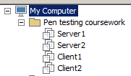

- Then browse to http://192.168.0.1/student and select your name.

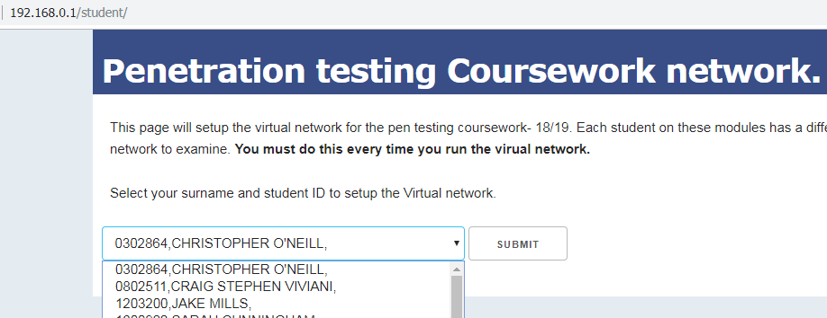

- Wait for around 60 seconds until you receive a message informing you that the machine has been set up.



- You have been provided with a test account on the system that you can use to log on to CLIENT2. The account details are username: test, password: test123.

The aim of this assessment is to conduct a white box penetration test to demonstrate the risks to the company network from a malicious insider, i.e. someone who has plugged a machine into the network. You have been paid to do ~20 hours of investigative work and you should allocate your time accordingly. In addition to conducting the practical work, you should write a report that documents your findings.

In your report, you should present your methodology, any interesting information that you have found about the state of security of the company network and countermeasures to any vulnerabilities that you may have found.

The report should efficiently describe the practical work you have undertaken in the format of a white paper (a proforma will be supplied). The report is aimed at the Network Administrator of the company (i.e. they are experienced in Computer Networking and have some knowledge of security).
As a suggestion, your document should include: -

- Abstract.
- Introduction
  - Introduction to the problem.
  - Aim of your work.
  - A definition of the methodology that you will adopt (define each steps and the tools that you will use). The methodology should be clear.
- Procedure and results
  - In essence, this section should explain what you did and what you found.
  - The results should be presented in an easy to read format.
  - Include any relevant screenshots. These should be clearly labelled and referenced within the text of your report.
- Discussion
  - Evaluate the results and their implications for the security of the network.
  - Any future investigative work that you would have undertaken given time.
  - Any countermeasures.
- References
- Appendices
  - Any large volume of information should be included in Appendices (e.g. Nessus outputs).

As in a real situation, there is no word limit. The document should efficiently and effectively describe your work and findings.
Submission Details
Your report, in word or pdf format should be submitted via the Module Assignment links on Blackboard before the deadline.

This coursework meets the following learning outcomes:
1. Undertake research to select appropriate methods of investigating the security of a computer network.
2. Evaluate and assess the security of a typical computer system.
3. Document details of an ethical hacking methodology.

Grading Scheme

Grades | Comment | Criteria
A/A+ | Excellent | Clear and complete understanding of examining security on a network. Decisions made are logical. Documentation is clear and concise. Any countermeasures are clear and concise. Project could easily be replicated by a peer.
B/B+ | Very Good | Clear and almost complete understanding of network security testing concepts. Documentation is clear. Relevant countermeasures are discussed.  Project could be replicated by a peer.
C/C+ | Good | A good overall understanding of network security. Some of the more integrative aspects or detailed knowledge may be missing. Documentation covers the project work. Some countermeasures are discussed. Project could be replicated by a peer with a little research.
D/D+ | Satisfactory | A basic overall understanding of network security. Documentation covers the topic but may lack in areas (e.g. future work or discussion). Countermeasures are discussed but may not be comprehensive.  Project could be replicated by a peer with some research.
MF | Marginal Fail | A basic understanding of some aspects of network security. Knowledge of details and of integrative concepts may be largely missing. Project could not be replicated by a peer.
F | Clear Fail | A poor or confused knowledge of the material.
NS | No submission
General University Grading Criteria

Literal grade | Grade point | Evaluative descriptor | ECTS
A+ | 4.5 | Excellent overall.  - Demonstrates an excellent grasp of the subject matter.  - Excellent capacity for original and creative enquiry.  - Excellent ability to critically evaluate, analyse, synthesise and integrate complex information.  - Excellent communication skills.  In addition, exceptional in at least one of the above. | A
A | 4 | Excellent overall.  - Demonstrates an excellent grasp of the subject matter.  - Excellent capacity for original and creative enquiry.  - Excellent ability to critically evaluate, analyse, synthesise and integrate complex information.  - Excellent communication skills. | A
B+ | 3.5 | Very good overall.  - Demonstrates a very good grasp of the subject matter.  - Very good capacity for original and creative enquiry.  - Very good ability to critically evaluate, analyse, synthesise and integrate complex information.  - Very good communication skills.  In addition, excellent in at least one of the above but overall performance deemed to be very good. | B
B | 3 | Very good overall.  - Demonstrates a very good grasp of the subject matter.  - Very good capacity for original and creative enquiry.  - Very good ability to critically evaluate, analyse, synthesise and integrate complex information.  - Very good communication skills. | B
C+ | 2.5 | Good overall.  - Demonstrates a good grasp of the subject matter.  - Good capacity for original and creative enquiry.  - Good ability to critically evaluate, analyse, synthesise and integrate complex information.  - Good communication skills  In addition, very good in at least one of the above but overall performance deemed to be good. | C
C | 2 | Good overall.  - Demonstrates a good grasp of the subject matter.  - Good capacity for original and creative enquiry.  - Good ability to critically evaluate, analyse, synthesise and integrate complex information.  - Good communication skills | C
D+ | 1.5 | Satisfactory overall.  - Demonstrates a satisfactory grasp of the subject matter but limited grasp in some areas  - Satisfactory capacity for original and creative enquiry.  - Satisfactory ability to critically evaluate, analyse, synthesise and integrate information.  - Satisfactory communication skills | D
D | 1 | Adequate.  Achievement of all threshold standards but grasp of some subject areas and graduate attribute development may be more limited. | D
MF | 0.5 | Marginal fail.  Performance just below the threshold standard. A reasonable expectation that a pass is achievable by reassessment without the need to repeat the module. | FX
F | 0 | Performance well below the threshold level. Some limited evidence of achievement of the outcomes. | F
NS |  | No assessments submitted.

